**DE LA SALLE UNIVERSITY - MANILA**

**Cholesterol Ratio Calculator**

___________________________________

A Term Project

Presented to Mr. Ramon Stephen L. Ruiz

In Partial Fulfillment of the

Requirements for the Course Programming Logic and Design (PROLOGI)

___________________________________

by

CHUA, Ellis Dominic P. -

DE RAMOS, Johann Miguel S. - 

SIMBULAN, Gabrielle C. - Signature/Initials -

EQ3

MH 12:45 - 1:45

April 2023

**RUBRIC FOR THE TERM PROJECT**

|  |  |  |  |  |  |
| --- | --- | --- | --- | --- | --- |
| CRITERIA | EXEMPLARY (90-100) | SATISFACTORY (80-89) | DEVELOPING (70-79) | BEGINNING  (60-69) | WEIGHT |
| Experimental Plan (Flowchart/ Algorithm) | Experimental  plan has  supporting  details and  diagram/  algorithm that are stated and well-explained | Experimental  plan has supporting  details and  a diagram/  algorithm that is  stated but not  explained | Experimental  plan is vague  or brief. It has  supporting  details and  does not have  a diagram/  algorithm | No  experimental  plan  presented | 20% |
| Codes/Data/ Program | The program  utilized some  appropriate  models or  equations to in  solving problems.  Data is well  utilized in the  program.  Program codes  are easy to read. Program output has no error. Questions are  answered  completely and correctly | The program  barely utilized  some equations  in solving  problems.  Data is somewhat  utilized in the  program. Program code are easy to read. Program output has output but is logically incorrect. Some  questions are  answered  completely and  correctly | Data is not  utilized in the  program. It has a missing  significant  code/syntax in  the program. | No program  presented | 30% |
| Use of Appropriate Tools and Techniques | Appropriate  tools and  techniques are  properly used  for all aspects of the project | Appropriate  tools and  techniques are  used in most of  the aspects of  the project and  all of these are used properly | Appropriate  tools and  techniques are  used in the majority of  the aspects of the project and all of these are used properly | Appropriate  tools and  techniques  are used in  less than half  of the aspects  of the project and/or tools are not used in at least half the aspects of the project | 10% |
| Project Documentation | Project  documentation  is orderly  presented  starting from  statement of the problem, to  objective of the project,  followed by  review of  literature, design  consideration,  presentation of  data or output  and conclusion.  The report was  grammatically  correct,  logically  presented and  used the  required format. | Project  documentation  is complete with  statement of the  problem,  objectives,  design  consideration,  presentation of  data and output  and conclusion.  The report had  minimal  grammatical  errors and  somewhat  presented  logically. The  required format  was used. | Project  documentation  is basically  limited to  algorithm  presentation of  data and  output but no  basis of the  design was  presented.  The report had  a lot of  grammatical  errors and not  logically  presented; the  required  format was  barely used. | Project  documentation is not  reflective of  algorithm  design and/or  characterizationThe  report had a  lot of  grammatical  errors, was  not logically  presented  and the  required  format was  not used. | 30% |
| Project Presentation | Project  presentation is  complete and  backed up by  complete design  consideration,  logic  formulation and  review of  related literatur | Project  presentation is  complete with  algorithm  simulation  results backed  up by design  considerations. | Project  presentation  shows a  system  completely  simulated but  is not backed  up by clear  explanation of  how algorithm  was derived | Project  presentation  lacks clarity  in terms of  presenting  and  characterizin  g the  behavior of  the algorithm | 10% |

**TABLE OF CONTENTS**

**I. Introduction 4**

A. Background of the Study 4

B. Problem Statement 5

C. Objectives 6

C.1 General Objective 6

D. Significance of the Project 6

**II. Review of Related Literature 6**

**III. Methodology 7**

A. Conceptual Framework 7

B. Hierarchy Chart 9

C. Flowchart 10

D. Pseudocode 11

**IV. Results 16**

**V. Discussion of Results 21**

**VI. Analysis, Conclusion, and Future Directives 21**

**References 22**

**Appendices 22**

A. User’s Manual 22

B. Source Code 23

C. Work breakdown 40

D. Personal Data Sheet 42

**List of Figures**

Figure 1: Hierarchy Chart 9

Figure 2: Flowchart10

**List of Tables**

Table 1: IPO Chart7

Table 2: Work breakdown40

# Introduction

Due to cardiovascular diseases being the most common cause of death in the country, it's important to monitor our cholesterol intake. According to the World Health Organization, 39% of individuals worldwide had elevated total cholesterol in 2008. Moreover, according to a study from the Department of Science and Technology's Food and Nutrition Research Institute (DOST-FNRI), nearly 46.9% of Filipinos who are 20 years of age and older have borderline high cholesterol. The cholesterol ratio plays a significant role in predicting a person's risk of developing heart disease and stroke. This can be caused by unhealthy food choices, smoking, heredity, age, and lack of physical activity. Users can determine their Low-Density Lipoprotein (LDL) to High-Density Lipoprotein (HDL) ratio, triglycerides to HDL ratio, and total cholesterol ratio to HDL ratio with the cholesterol ratio calculator. The goal of the calculator is to give users a tool to be able to measure their cholesterol levels and help diagnose, screen for, and monitor certain health conditions that concern cholesterol levels.

A Basic Metabolic Panel (BMP) is a test that measures eight different substances present in the blood, and it may be used to determine the level of these three cholesterol levels, which should be expressed in milligrams per deciliter(mg/dL). Using the three values, the user may compute the total cholesterol value by multiplying the triglyceride value by the sum of the LDL and HDL. To calculate the ratio, the total cholesterol value is simply divided by the HDL value; the same goes for LDL and triglycerides.

## Background of the Study

Cholesterol is a naturally occurring, fatty substance that is present in all cells of the body. While the body needs some cholesterol to produce hormones, vitamin D, and other substances that aid digestion, excessive levels of cholesterol can have detrimental effects on health. The body is capable of producing all the cholesterol it needs, and additional cholesterol can be obtained through the consumption of animal-based foods such as meat, cheese, and egg yolks. When cholesterol levels in the blood are too high, it can combine with other substances to form plaque.

Lipoproteins are complex structures composed of proteins and lipids, which are necessary for their transport in the bloodstream. HDL, also known as high-density lipoprotein, is commonly referred to as good cholesterol. HDL carries cholesterol from various parts of the body and transports it back to the liver. The liver then processes and eliminates the cholesterol from the body. HDL is considered beneficial because it helps to remove excess cholesterol from the bloodstream, reducing the risk of developing atherosclerosis. a condition in which plaque builds up walls in the arteries, leading to various cardiovascular diseases.

LDL or low-density lipoprotein is often referred to as bad cholesterol due to its potentially harmful effects on health. A high level of LDL in the bloodstream is associated with the buildup of plaque in the arteries, leading to atherosclerosis. LDL is produced in the liver and is responsible for carrying cholesterol from the liver to various parts of the body, including the arteries. When the LDL levels are high, the excess cholesterol is deposited on the walls of the arteries, leading to the formation of plaque, which can eventually obstruct blood flow and cause a range of cardiovascular diseases.

Triglycerides are a form of fat that can be found in the bloodstream, either produced by the body or obtained through the diet. While triglycerides are necessary for good health, high levels of triglycerides in the bloodstream can increase the risk of developing heart disease and stroke.

The cholesterol ratio can be used to assess an individual's risk of developing heart disease. The ideal ratio for total cholesterol to HDL is less than 4. It can also be considered good if the ratio is between 4 and 5, while a ratio above 5 is high. For the LDL to HDL ratio, an ideal ratio is less than 3. Between 3 and 4 is considered high, while above 4 is too high and is indicating a risk of developing heart disease. For Triglyceride to HDL ratio, the ideal ratio is less than 2, a ratio between 2 and 3 is considered high, while a ratio above 3 is high. Having a high cholesterol ratio, particularly a high LDL to HDL ratio, can lead to the development of atherosclerosis and an increased risk of heart disease and stroke. Other factors such as age, gender, blood pressure, family history, smoking status, and diabetes also play a role. If you have concerns about your cholesterol levels, speak with your healthcare provider who can perform a full evaluation and develop a plan for managing your cholesterol levels and reducing your risk of heart disease.

## Problem Statement

According to the Philippine Statistics Authority, cardiovascular diseases (CVDs) in the Philippines remain the leading cause of death in the country with 77, 173 deaths recorded from the start of 2022, to the 3rd quarter of the same year. The prevalence of CVDs is also quite high, as one of its main risk factors are high unregulated amounts of cholesterol in the body. High cholesterol levels are linked with diabetes and hypertension, and quite a large population has these diseases. 19.2% of adults between 20-59 years of age, and 35% of those aged 60 years and above have hypertension.

The lack of awareness and understanding towards the importance of maintaining healthy cholesterol levels is a contributing factor to the portion of the population that is inflicted with CVDs. In order to combat this, citizens must be urged to monitor their cholesterol levels. The results given by Cholesterol Ratio Calculator may be used as a reference in deciding whether to book a doctor's appointment or not, and to attempt a healthier lifestyle. The calculator can serve as an instrument to promote health literacy, which can also lower the country’s mortality rate in the long run.

## Objectives

## C.1 General Objective

The general objective of the program is to propose a device that will help people monitor their cholesterol. It is a tool that assists users in calculating their cholesterol levels and ratios and assessing their risk for heart disease. The program can let them know users when to get a checkup with a doctor, allowing them to take action if necessary as soon as possible

**C.2** **Specific Objectives**

For the specific objectives, the program gives users a detailed description of what each ratio shows and provides users with suggestions and recommendations of actions they can take to further care for their body and improve their lifestyle and health. Additionally, with the information given by the program, the users will be educated on the importance of maintaining healthy cholesterol levels, impact of diet and exercise on their cardiovascular health. With this the users may know the potential risk and benefits associated with them.

## Significance of the Project

The Cholesterol Ratio Calculator provides a simple way that can help individuals monitor their cholesterol levels. Since heart disease is common that goes along with an unhealthy diet and lifestyle, it is important to be informed of what one’s body is possibly at risk of so that one can take immediate action to get themselves checked. The calculator also provides encouragement to improve and change the individual’s lifestyle.

# Review of Related Literature

An article published by the National Nutrition Council explains that Cholesterol is a type of lipid that is responsible for the production of cell membranes, vitamin D, and certain hormones. This lipid cannot independently move through the blood, so the liver produces lipoproteins to assist in cholesterol transportation. There are 2 types of lipoprotein: Low-density lipoprotein (LDL) and High-density lipoprotein (HDL). The LDL cholesterol is made of fat, and is considered the “bad” cholesterol. On the other hand, the HDL cholesterol is composed of protein, and is called the “good” cholesterol.

A survey conducted by Philippine Heart Association showed that hypertension has the highest incidence of cardiovascular diseases (CVDs) in the Philippines. Buildup of cholesterol plaque in the arteries causes it to become narrow and rigid. Another survey from the Philippine and Philippine-American Health Statistics, 6% of Filipinos have Type 2 Diabetes, and hypertension affects 1 in 4 Filipinos. High rates of CVD are linked with detrimental health habits that include alcohol consumption and poor diet and nutrition. The average amount of salt in a Filipino diet is 12 grams, also considering the high quantity of carbohydrates and cholesterol.

The total/HDL cholesterol ratio, also referred to as the Castelli index, and the LDL/HDL cholesterol ratio are the indicators of possible vascular complications. The mentioned ratio may produce a more accurate value if triglycerides are also taken into account. A study called LRC-CPPT was conducted to further investigate the predictive ability of the total/HDL cholesterol ratio and LDL/HDL cholesterol and to compare it with other lipid metabolism variables. The participants were divided into deciles, then shortly into tertiles using end-points. The results showed that when the total cholesterol and LDL cholesterol were assigned as primary end-points, the LDL/HDL ratio and total cholesterol/HDL ratio identified high and low risk groups. The two aforementioned measures are also good predictors of the extent of clinical benefit from attempts to lower their lipid levels (Millán et al., 2009).

# Methodology

## Conceptual Framework

|  |  |  |
| --- | --- | --- |
| Input | Process | Output |
| option - user input to select whether to login or register  fname - user input for their first name  lname - user input for their last name  username - user input for their username  password - user input for their password  hdl - user input for their HDL value  ldl - user input for their LDL value  tgyd - user input for their triglyceride value  mmol - user input for cholesterol levels in millimoles per liter  r1, r2, r3, r4 - user input to select whether to loop the program | 1. Based on the user selection, the program will proceed to the login or registration section. 2. If the user chooses to register, the program will ask for the user’s first name, last name, username, and password. It will save these details in a .txt file and proceed to the calculator. 3. If the user chooses to login, the program will ask the user to input their username and password and check if these details are in the .txt file and compare them. If the details do not match or do not exist in the .txt file, the login will fail, otherwise, the program will proceed to the calculator 4. The calculator program will first ask the user if they want to use the mmol/L to mg/dL since the program calculates the ratio using mg/dL as its unit of measurement. 5. The calculator will then ask the user to input the values of their HDL, LDL, and triglycerides 6. The calculator will compute and display the total cholesterol, the cholesterol/HDL ratio, the LDL/HDL ratio, and the triglyceride/HDL ratio. 7. Based on the rato, the calculator will also display a description, an exercise plan, and a diet plan 8. Finally, the program will ask the user if they want to use the calculator again and if they want to use another account. | login.txt file - file where the user details are stored.  measurement converted cholesterol levels  Total Cholesterol value  Cholesterol/HDL ratio  LDL/HDL ratio  Triglyceride/HDL ratio  Description, diet plan, and exercise plan for each level of the LDL/HDL and Triglyceride/HDL ratio |



## Hierarchy Chart

## 

## Flowchart

<https://drive.google.com/file/d/111diFw8jEoMoPaN_RkMwLJt3jRuHuK0C/view?usp=sharing>

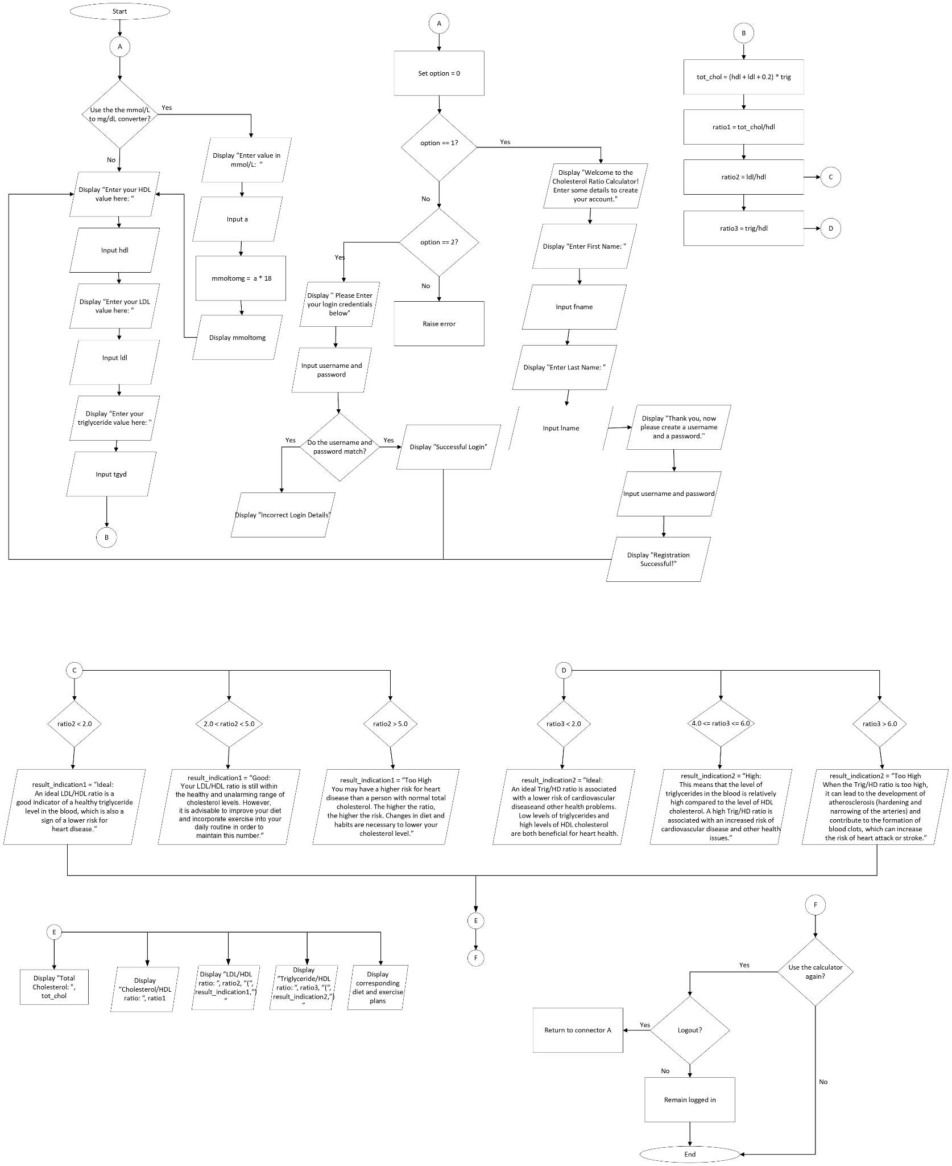



## Pseudocode

Module main()

Declare char r1, r2, r3, r4  
Declare float hdl, ldl, tgyd, mmol, mg  
Constant int loggedIn = 0

Do // Loops the whole program

Declare int option

// Selection Screen  
 Call line()  
 Display “Press ‘1’ to Register”  
 Display “Press ‘2’ to Login”  
 Call line()  
 Input option

If option == 1 Then

Clear screen  
 Call registration()  
 Set loggedIn = 1

Else if option == 2 Then

Clear screen  
 Call login()  
 Set loggedIn = 1

End if

Do // Loop for the calculator only

If loggedIn Then

Call line()  
 Display “CHOLESTEROL RATIO CALCULATOR”  
 Call line()

//Converter  
 Display “Would you like to use the converter”  
 Input r1  
 Call line()

If r1 == ‘Y’ Then

Display “MMOL/L TO MG/DL CONVERTER”  
Call line()

Do //Loop for the converter only

Display “Enter value in mmol/L”  
 Input mmol

Display Call mmoltomg(mmol), “mg/dL”

Display “Do you want to use the converter again?: “  
 Input r2  
 Call line()

While r2 == ‘Y”

// Ratio Calculator   
 Display “Enter your HDL level: “  
 Input hdl

Display “Enter your LDL level: “  
 Input ldl

Display “Enter your triglyceride level: “  
 Input tgyd

Clear screen

Call line()  
 Display “RESULTS”  
 Call line()

Display “Total Cholesterol: “, Call tot_chol(hdl, ldl, tgyd), “mg/dL”

Display “Cholesterol / HDL Ratio: “, Call ratio(tot_chol(hdl, ldl,tgyd), hdl)

Display “LDL / HDL Ratio: “, Call ratio(ldl, hdl)

Display Triglyceride / HDL Ratio: “, Call ratio(tgyd, hdl)

// Display the Description for each ratio

Call line()

Call ldlhdl(hdl, ldl)

Call line()

Call tgydhdl(hdl, tgyd)

Call line()

Display “Do you want to use the calculator again?: “  
 Input r3

Call line()

If r3 == ‘Y’ Then

Display “Would you like to logout?: “  
 Input r4

End if

Else

Display “Login failed. Please try again”  
 Set r3 = ‘Y’

End if

While r3 == ‘Y’ AND r4 == ‘N’

While r3 == ‘Y’ AND r4 == ‘Y’

End Module

Module line()

Display “------------------------------------------------------------------------”

End Module

Module mmoltomg(float a)

return (a * 18)

End Module

Module tot_chol(float a, float b, float c)

return (a + b +(0.2 * c))

End Module

Module ratio(float a, floatb)

return (a/b)

End Module

Module ldlhdl(float hdl, float ldl)

Declare float tot_ratio2

Set tot_ratio2 = ldl/hdl

If tot_ratio2 < 2.0 Then

Display the description, diet plan, and exercise plan for an ideal LDL/HDL ratio

Else if tot_ratio2 >= 2.0 AND tot_ratio2 < 5.0 Then

Display the description, diet plan, and exercise plan for a good LDL/HDL ratio

Else

Display the description, diet plan, and exercise plan for an LDL/HDL ratio that is too high

End If

End Module

Module tgydhdl(float hdl, float tgyd)

Declare float tot_ratio3

Set tot_ratio3 = tgyd/hdl

If tot_ratio3 < 2.0 Then

Display the description, diet plan, and exercise plan for an ideal triglyceride/HDL ratio

Else if tot_ratio3 >= 4.0 AND tot_ratio2 < 6.0 Then

Display the description, diet plan, and exercise plan for a high triglyceride/HDL ratio

Else

Display the description, diet plan, and exercise plan for an triglyceride/HDL ratio that is too high

End If

End Module

Module login()

Declare char username, password

Display “Please enter your login credentials below”

Display “Username: “  
Input username

Display “Password: “  
Input password

If username == l.username AND password == l.password Then

Display “Successful Login”  
 Display “Press any key to continue”  
 Clear screen

Else

Display “Incorrect Login Details:

End If

End Module

Module registration()

Declare char fname, lname, username, password

Display “Welcome to the Cholesterol Ratio Calculator!”  
Display “Enter some details to create your account”

Display “Enter First Name: “  
Input fname

Display “Enter Surname: “  
Input lname

Display “Enter username: “  
Input username

Display “Enter password: “  
Input password

Display “Registration Successful!”  
Display “Press any key to continue”  
Clear screen

End Module

# Results

Selection Screen:

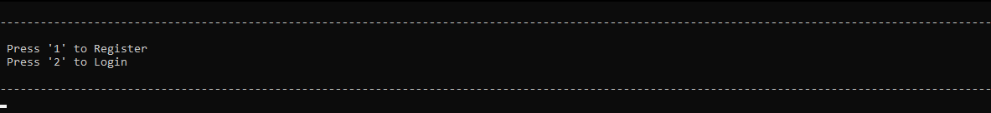

Registration Screen:

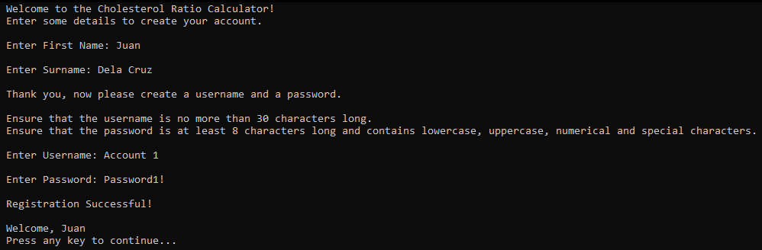

Successful Login Screen:

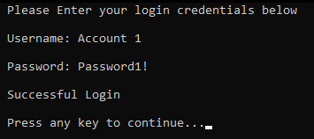

Unsuccessful Login Screen:

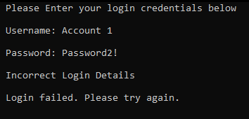

Converter and Calculator Screen:

1.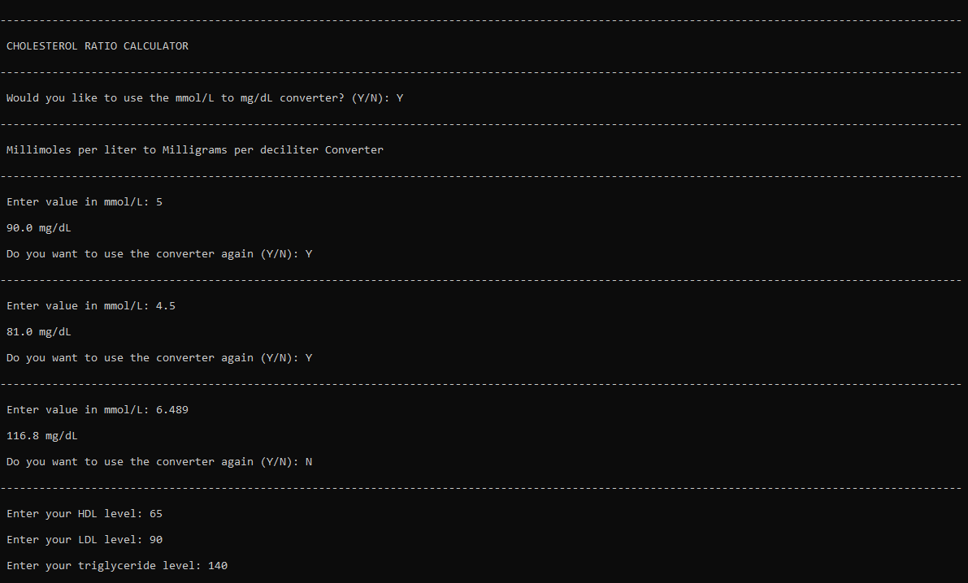

2.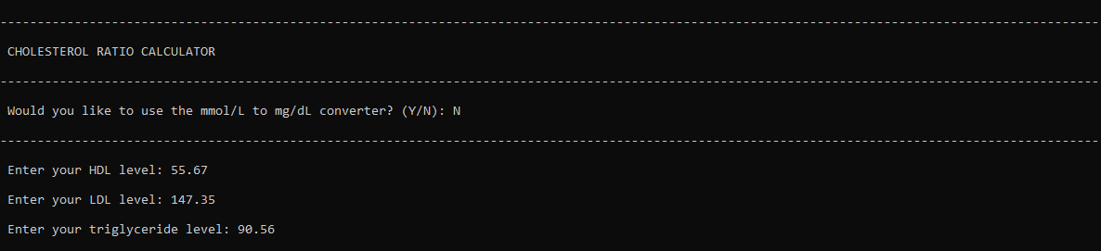

3.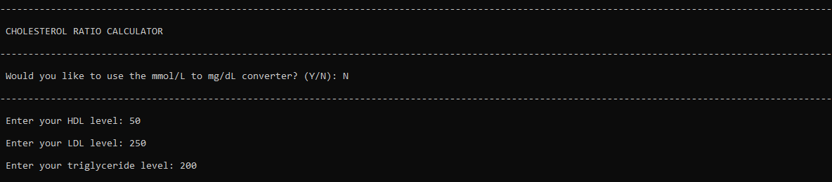

Results Screen:

1.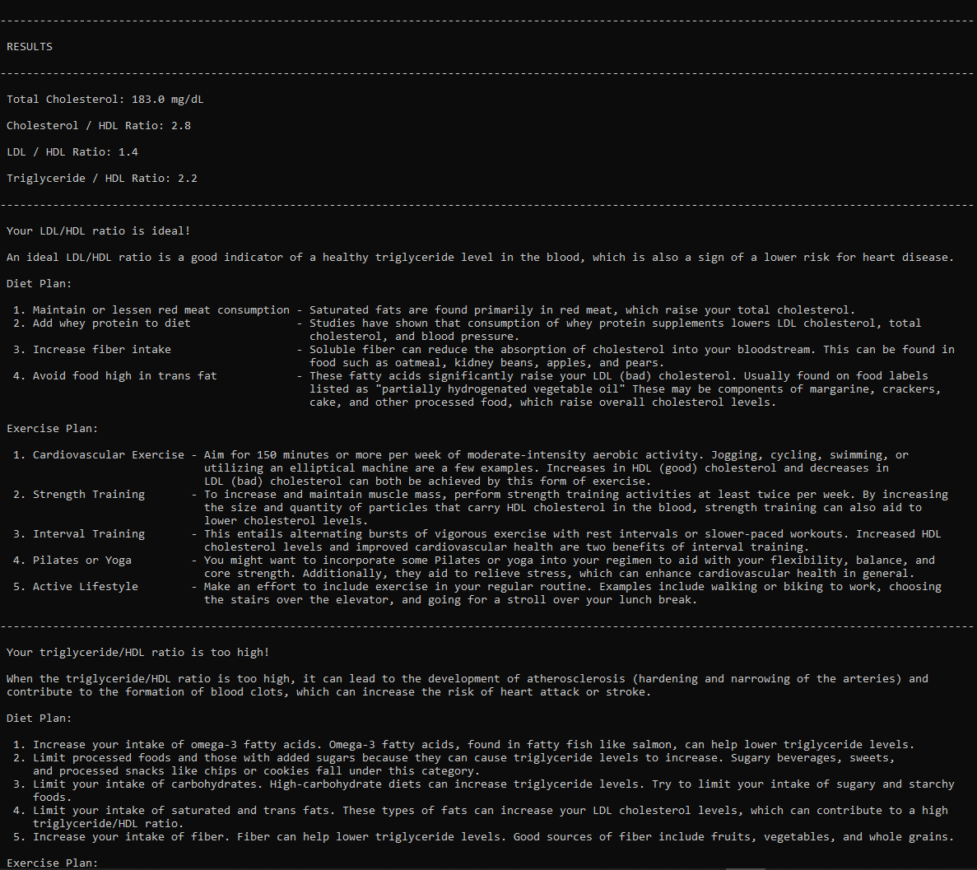

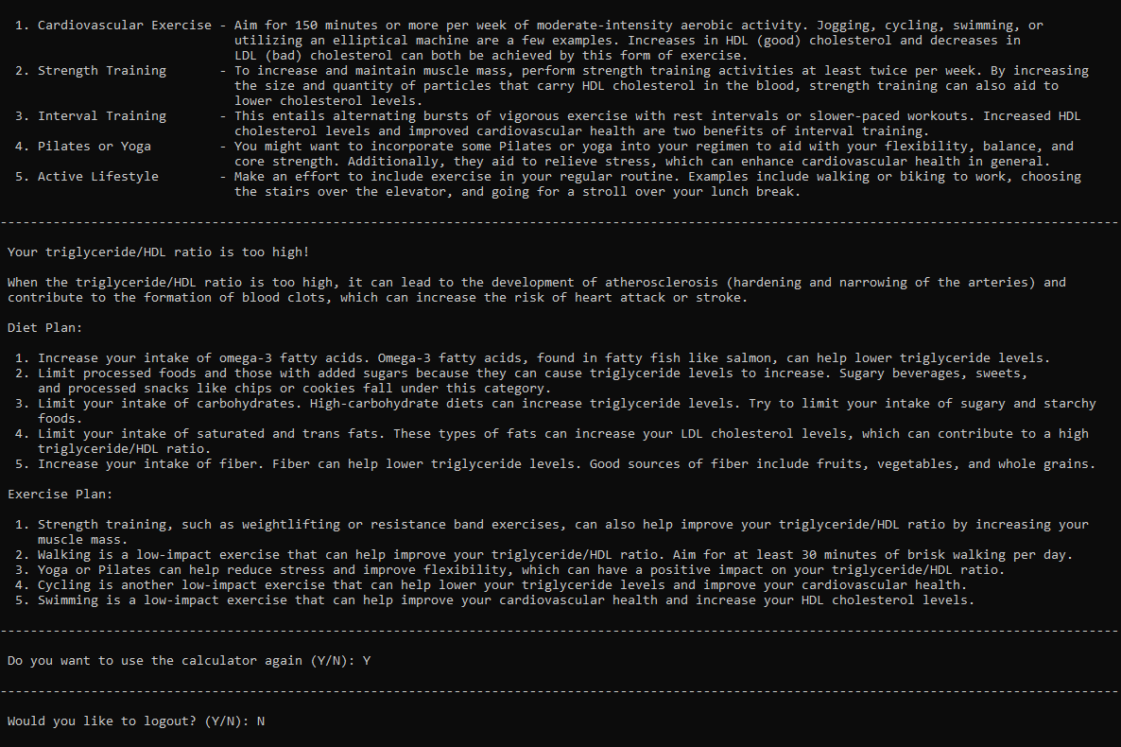

2.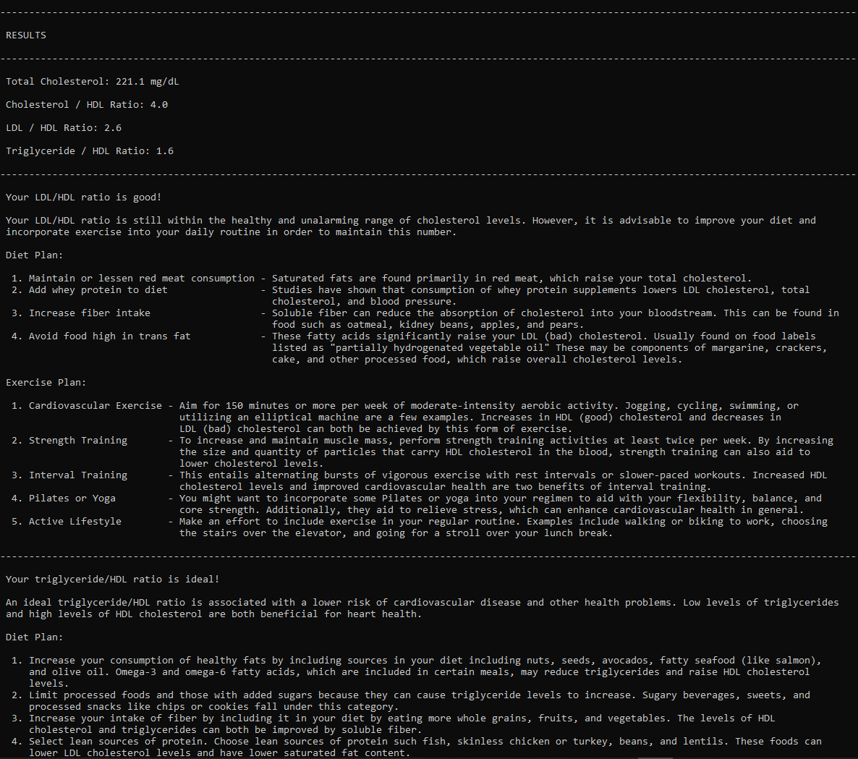



3.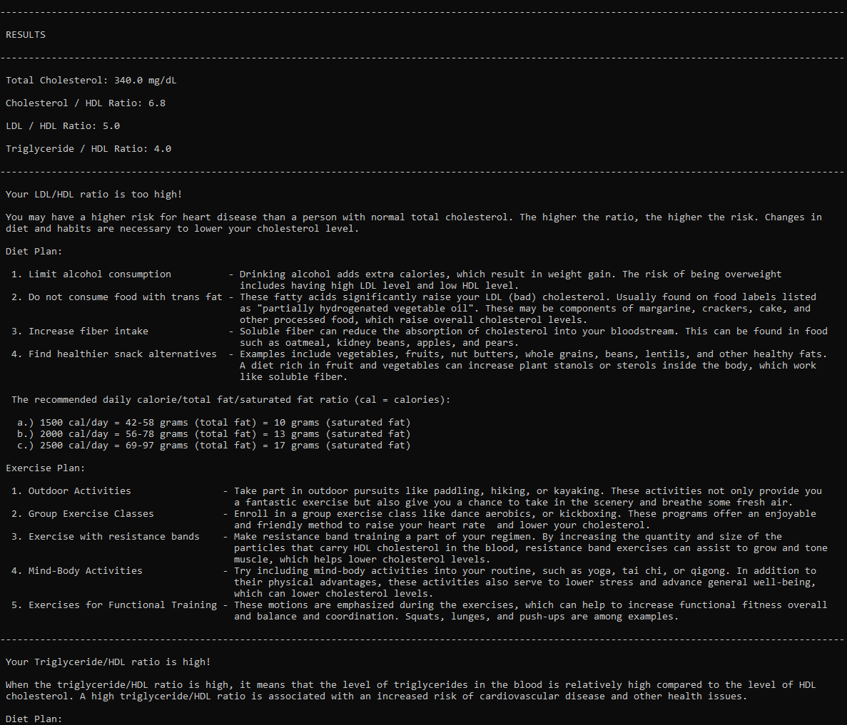

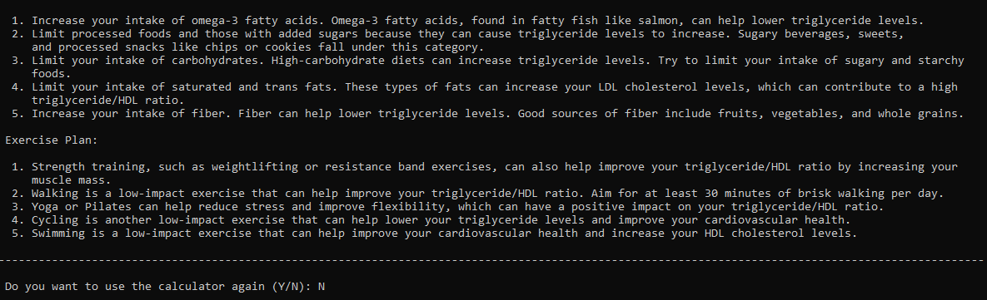

# Discussion of Results

The main purpose of the application was to calculate the total cholesterol, total/HDL cholesterol ratio, and triglyceride/HDL ratio based on the user input. The program also has an mmol/L to mg/dL converter, making it more convenient in case the user does not have the correct unit of measurement. Moreover, another one of its features is the user registration, and the saving of results to the account registered. Because of this, users can access their data anytime, provided that they provide the correct log-in details. The calculator does not only compute the ratio of cholesterol components, but also provides general diet and exercise suggestions on how to improve cholesterol levels, based on the result indications the user will receive. The output of the program can serve as a basis for the user either to follow and do more research in order to improve their cardiovascular health, but also in deciding whether a doctor’s appointment is necessary or not. Upon executing the Cholesterol Ratio Calculator, all of the features and objectives proposed were achieved.

# Analysis, Conclusion, and Future Directives

The program was created using the C language through the Dev-C++ application. Initially, the code will import the necessary libraries, in this case the “projecth.h” file and “stdio.h”, among many others. In order to save log-in details, a new file will be created and referred to during log-in. A user prompt will then appear regarding registration or log-in. After making an account or logging in, a unit converter for mmol/L to mg/dL will be available. After the user makes a choice, the input for the LDL, HDL, and Triglyceride values will be needed. The program will compute all of the ratios using the respective equations put in the code. The different equations were put in individual modules for the code to be easier to interpret and organize. Both the LDL/HDL cholesterol and Triglyceride/HDL ratio will have a result indication, along with a diet plan and an exercise plan. The ratio for the total/HDL cholesterol will also be calculated but no meal or diet plan will be provided. The output of the program will be a user account, the ratios, result indication, and a diet plan and exercise plan recommendation.

In conclusion, the Cholesterol Ratio Calculator is a helpful tool that allows users to calculate their cholesterol levels and ratios, convert units of measurement, and access results through a user account. It also provides useful suggestions for diet and exercise to improve cardiovascular health based on the user's results. Overall, the program successfully achieves its intended objectives and can serve as a useful resource for individuals seeking to monitor and improve their cholesterol levels.

# References

Caprio S. (2011). *The Triglyceride-to-HDL Cholesterol Ratio: Association with insulin resistance in obese youths of different ethnic backgrounds.*Retrieved from diabetesjournals.org:<https://diabetesjournals.org/care/article/34/8/1869/27732/The-Triglyceride-to-HDL-Cholesterol>

Havel J. (1988). *Lowering Cholesterol.* Retrieved from: [*https://dm5migu4zj3pb.cloudfront.net/manuscripts/113000/113501/JCI88113501.pdf*](https://dm5migu4zj3pb.cloudfront.net/manuscripts/113000/113501/JCI88113501.pdf)

Navab M., Reddy S., Lenten B., Fogelman A.(2011). *HDL and cardiovascular disease:artherogenic and artheroprotective mechanism.* Retrieved from nature.com:<https://www.nature.com/articles/nrcardio.2010.222>

Mouritsen O., Zuckermann M.(2004). *What’s so special about cholesterol? Retrieved from onlinelibrary.wiley.com:* [*https://aocs.onlinelibrary.wiley.com/doi/abs/10.1007/s11745-004-1336-x*](https://aocs.onlinelibrary.wiley.com/doi/abs/10.1007/s11745-004-1336-x)

Bialek L., Szyk B., Koperska M. Bowater J. Last updated Jan. (2023). *Cholesterol Ratio Calculator.* Retrieved from omnicalculator.com: [*https://www.omnicalculator.com/health/cholesterol-ratio*](https://www.omnicalculator.com/health/cholesterol-ratio)

Nauck M., Warnick R., Rifai N. (2002). *Methods for measurement of LDL-Cholesterol: A Critical assessment of direct measurement by homogenous assays versus calculation.* Retrieved from academic.oup.com: [*https://academic.oup.com/clinchem/article/48/2/236/5641549*](https://academic.oup.com/clinchem/article/48/2/236/5641549)

# Appendices

## User’s Manual

The Cholesterol Ratio Calculator is a simple program that helps you calculate your cholesterol level and ratios. This program can calculate your total cholesterol level, cholesterol/HDL ratio, LDL/HDL ratio, and triglyceride/HDL ratio. Since the program uses values in mg/dL in calculating, there is also a mmol/L to mg/dL converter feature.

Once the program is running, you will be presented with two options: Register or Login.

If you select the Register option, the program will ask for your first and last name, username, and password. Once you fill out all the fields, your account will be created, and you will be logged in automatically.

If you have already registered, select the Login option, and the program will ask you to enter your username and password. Once you enter the correct credentials, you will be logged in.

Once logged in, you will be presented with the Cholesterol Ratio Calculator which will first ask you if you want to use the mmol/L to mg/dL converter. Enter ‘Y’ for yes and ‘N’ for no.

The program will then ask for your HDL, LDL, and triglyceride levels. Once you enter these values, the program will calculate and display the total cholesterol level, cholesterol/HDL ratio, LDL/HDL ratio, and triglyceride/HDL ratio. It will also display recommended diet and exercise plans based on your ratio.

To repeat the program or a section of the program, once again enter either ‘Y’ for yes and ‘N’ for no.

## Source Code

*Main File:*

#include <stdio.h>  
 #include <string.h>  
 #include <stdlib.h>  
 #include <unistd.h>  
 #include "projecth.h"

int main() {

char r1, r2, r3, r4;

float hdl, ldl, tgyd, mmol, mg;

int loggedIn = 0;

do {

int option;

// Selection Screen

line();

printf("\n Press '1' to Register");

printf("\n Press '2' to Login\n");

line();

scanf("%d",&option);

getchar();

if(option == 1) {

system("CLS");

if (registration()) {

loggedIn = 1;

}

}

else if(option == 2) {

system("CLS");

if (login()) {

loggedIn = 1;

}

}

// Ratio Calculator

do {

if (loggedIn) { // Will only proceed to the calculator if login/registration was successful

line();

printf("\n CHOLESTEROL RATIO CALCULATOR\n");

line();

// Converter

printf("\n Would you like to use the mmol/L to mg/dL converter? (Y/N): ");

scanf(" %c", &r1);

line();

if (r1 == 'Y') {

printf("\n Millimoles per liter to Milligrams per deciliter Converter\n");

line();

do {

printf("\n Enter value in mmol/L: ");

scanf("%f", &mmol);

printf("\n %.1f mg/dL \n", mmoltomg(mmol));

printf("\n Do you want to use the converter again (Y/N): ");

scanf(" %c", &r2);

line();

} while (r2 == 'Y');

}

printf("\n Enter your HDL level: ");

scanf("%f", &hdl);

printf("\n Enter your LDL level: ");

scanf("%f", &ldl);

printf("\n Enter your triglyceride level: ");

scanf("%f", &tgyd);

system("CLS");

// Display of Results and Descriptions

line();

printf("\n RESULTS\n");

line();

printf("\n Total Cholesterol: %.1f mg/dL\n", tot_chol(hdl, ldl, tgyd));

printf("\n Cholesterol / HDL Ratio: %.1f\n", ratio(tot_chol(hdl, ldl, tgyd), hdl));

printf("\n LDL / HDL Ratio: %.1f\n", ratio(ldl, hdl));

printf("\n Triglyceride / HDL Ratio: %.1f\n", ratio(tgyd, hdl));

line();

// Description for LDL / HDL Ratio

ldlhdl(hdl, ldl);

line();

// Description for triglyceride / HDL Ratio

tgydhdl(hdl, tgyd);

line();

// Prompt to end or loop the program

printf("\n Do you want to use the calculator again (Y/N): ");

scanf(" %c", &r3);

line();

// Avoids the inconvenience of logging in again when the program loops

if (r3 == 'Y') {

printf("\n Would you like to logout? (Y/N): ");

scanf(" %c", &r4);

system("CLS");

}

}

else {

printf("\n Login failed. Please try again.\n");

r3 = 'Y';

}

} while (r3 == 'Y' && r4 == 'N');

} while (r3 == 'Y' && r4 == 'Y');

return 0;

}

*Header File:*

// Line Function

void line() {

printf("\n----------------------------------------------------------------------------------------------------------------------------------------------------\n");

}

// Converter Formula

float mmoltomg(float a) {

return (a * 18);

}

// Total Cholesterol Formula

float tot_chol(float a, float b, float c) {

return( a + b + (0.2 * c));

}

// Ratio Formula

float ratio(float a, float b) {

return (a / b);

}

// LDL/HDL Ratio Description

char ldlhdl(float hdl, float ldl) {

float tot_ratio2;

tot_ratio2 = ldl/hdl;

if (tot_ratio2 < 2.0) {

printf("\n Your LDL/HDL ratio is ideal!");

printf("\n");

printf("\n An ideal LDL/HDL ratio is a good indicator of a healthy triglyceride level in the blood, which is also a sign of a lower risk for heart disease.");

printf("\n");

printf("\n Diet Plan: ");

printf("\n");

printf("\n 1. Maintain or lessen red meat consumption - Saturated fats are found primarily in red meat, which raise your total cholesterol.");

printf("\n 2. Add whey protein to diet- Studies have shown that consumption of whey protein supplements lowers LDL cholesterol, total");

printf("\n cholesterol, and blood pressure.");

printf("\n 3. Increase fiber intake - Soluble fiber can reduce the absorption of cholesterol into your bloodstream. This can be found in");

printf("\n food such as oatmeal, kidney beans, apples, and pears.");

printf("\n 4. Avoid food high in trans fat- These fatty acids significantly raise your LDL (bad) cholesterol. Usually found on food labels");

printf("\n listed as \"partially hydrogenated vegetable oil\" These may be components of margarine, crackers,");

printf("\n cake, and other processed food, which raise overall cholesterol levels.");

printf("\n");

printf("\n Exercise Plan: ");

printf("\n");

printf("\n 1. Cardiovascular Exercise - Aim for 150 minutes or more per week of moderate-intensity aerobic activity. Jogging, cycling, swimming, or");

printf("\n utilizing an elliptical machine are a few examples. Increases in HDL (good) cholesterol and decreases in");

printf("\n LDL (bad) cholesterol can both be achieved by this form of exercise.");

printf("\n 2. Strength Training- To increase and maintain muscle mass, perform strength training activities at least twice per week. By increasing");

printf("\n the size and quantity of particles that carry HDL cholesterol in the blood, strength training can also aid to");

printf("\n lower cholesterol levels.");

printf("\n 3. Interval Training - This entails alternating bursts of vigorous exercise with rest intervals or slower-paced workouts. Increased HDL");

printf("\n cholesterol levels and improved cardiovascular health are two benefits of interval training.");

printf("\n 4. Pilates or Yoga- You might want to incorporate some Pilates or yoga into your regimen to aid with your flexibility, balance, and");

printf("\n core strength. Additionally, they aid to relieve stress, which can enhance cardiovascular health in general.");

printf("\n 5. Active Lifestyle - Make an effort to include exercise in your regular routine. Examples include walking or biking to work, choosing");

printf("\n the stairs over the elevator, and going for a stroll over your lunch break.\n");

}

else if (tot_ratio2 >= 2.0 && tot_ratio2 < 5.0 ) {

printf("\n Your LDL/HDL ratio is good!");

printf("\n");

printf("\n Your LDL/HDL ratio is still within the healthy and unalarming range of cholesterol levels. However, it is advisable to improve your diet and");

printf("\n incorporate exercise into your daily routine in order to maintain this number.");

printf("\n");

printf("\n Diet Plan: ");

printf("\n");

printf("\n 1. Maintain or lessen red meat consumption - Saturated fats are found primarily in red meat, which raise your total cholesterol.");

printf("\n 2. Add whey protein to diet- Studies have shown that consumption of whey protein supplements lowers LDL cholesterol, total");

printf("\n cholesterol, and blood pressure.");

printf("\n 3. Increase fiber intake- Soluble fiber can reduce the absorption of cholesterol into your bloodstream. This can be found in");

printf("\n food such as oatmeal, kidney beans, apples, and pears.");

printf("\n 4. Avoid food high in trans fat- These fatty acids significantly raise your LDL (bad) cholesterol. Usually found on food labels");

printf("\n listed as \"partially hydrogenated vegetable oil\" These may be components of margarine, crackers,");

printf("\n cake, and other processed food, which raise overall cholesterol levels.");

printf("\n");

printf("\n Exercise Plan: ");

printf("\n");

printf("\n 1. Cardiovascular Exercise - Aim for 150 minutes or more per week of moderate-intensity aerobic activity. Jogging, cycling, swimming, or");

printf("\n utilizing an elliptical machine are a few examples. Increases in HDL (good) cholesterol and decreases in");

printf("\n LDL (bad) cholesterol can both be achieved by this form of exercise.");

printf("\n 2. Strength Training- To increase and maintain muscle mass, perform strength training activities at least twice per week. By increasing");

printf("\n the size and quantity of particles that carry HDL cholesterol in the blood, strength training can also aid to");

printf("\n lower cholesterol levels.");

printf("\n 3. Interval Training- This entails alternating bursts of vigorous exercise with rest intervals or slower-paced workouts. Increased HDL");

printf("\n cholesterol levels and improved cardiovascular health are two benefits of interval training.");

printf("\n 4. Pilates or Yoga- You might want to incorporate some Pilates or yoga into your regimen to aid with your flexibility, balance, and");

printf("\n core strength. Additionally, they aid to relieve stress, which can enhance cardiovascular health in general.");

printf("\n 5. Active Lifestyle- Make an effort to include exercise in your regular routine. Examples include walking or biking to work, choosing");

printf("\n the stairs over the elevator, and going for a stroll over your lunch break.\n");

}

else {

printf("\n Your LDL/HDL ratio is too high!");

printf("\n");

printf("\n You may have a higher risk for heart disease than a person with normal total cholesterol. The higher the ratio, the higher the risk. Changes in");

printf("\n diet and habits are necessary to lower your cholesterol level.");

printf("\n");

printf("\n Diet Plan:");

printf("\n");

printf("\n 1. Limit alcohol consumption - Drinking alcohol adds extra calories, which result in weight gain. The risk of being overweight");

printf("\n includes having high LDL level and low HDL level.");

printf("\n 2. Do not consume food with trans fat - These fatty acids significantly raise your LDL (bad) cholesterol. Usually found on food labels listed");

printf("\n as \"partially hydrogenated vegetable oil\". These may be components of margarine, crackers, cake, and");

printf("\n other processed food, which raise overall cholesterol levels.");

printf("\n 3. Increase fiber intake- Soluble fiber can reduce the absorption of cholesterol into your bloodstream. This can be found in food");

printf("\n such as oatmeal, kidney beans, apples, and pears.");

printf("\n 4. Find healthier snack alternatives - Examples include vegetables, fruits, nut butters, whole grains, beans, lentils, and other healthy fats.");

printf("\n A diet rich in fruit and vegetables can increase plant stanols or sterols inside the body, which work");

printf("\n like soluble fiber.");

printf("\n");

printf("\n The recommended daily calorie/total fat/saturated fat ratio (cal = calories):");

printf("\n");

printf("\n a.) 1500 cal/day = 42-58 grams (total fat) = 10 grams (saturated fat)");

printf("\n b.) 2000 cal/day = 56-78 grams (total fat) = 13 grams (saturated fat)");

printf("\n c.) 2500 cal/day = 69-97 grams (total fat) = 17 grams (saturated fat)");

printf("\n");

printf("\n Exercise Plan:");

printf("\n");

printf("\n 1. Outdoor Activities- Take part in outdoor pursuits like paddling, hiking, or kayaking. These activities not only provide you");

printf("\n a fantastic exercise but also give you a chance to take in the scenery and breathe some fresh air.");

printf("\n 2. Group Exercise Classes- Enroll in a group exercise class like dance aerobics, or kickboxing. These programs offer an enjoyable");

printf("\n and friendly method to raise your heart rate and lower your cholesterol.");

printf("\n 3. Exercise with resistance bands - Make resistance band training a part of your regimen. By increasing the quantity and size of the");

printf("\n particles that carry HDL cholesterol in the blood, resistance band exercises can assist to grow and tone");

printf("\n muscle, which helps lower cholesterol levels.");

printf("\n 4. Mind-Body Activities- Try including mind-body activities into your routine, such as yoga, tai chi, or qigong. In addition to");

printf("\n their physical advantages, these activities also serve to lower stress and advance general well-being,");

printf("\n which can lower cholesterol levels.");

printf("\n 5. Exercises for Functional Training - These motions are emphasized during the exercises, which can help to increase functional fitness overall");

printf("\n and balance and coordination. Squats, lunges, and push-ups are among examples.\n");

}

return tot_ratio2;

}

// Triglyceride/HDL Ratio Description

char tgydhdl(float hdl, float tgyd) {

float tot_ratio3;

tot_ratio3 = tgyd/hdl;

if (tot_ratio3 < 2.0) {

printf("\n Your triglyceride/HDL ratio is ideal!");

printf("\n");

printf("\n An ideal triglyceride/HDL ratio is associated with a lower risk of cardiovascular disease and other health problems. Low levels of triglycerides");

printf("\n and high levels of HDL cholesterol are both beneficial for heart health.");

printf("\n");

printf("\n Diet Plan: ");

printf("\n");

printf("\n 1. Increase your consumption of healthy fats by including sources in your diet including nuts, seeds, avocados, fatty seafood (like salmon),"); printf("\n and olive oil. Omega-3 and omega-6 fatty acids, which are included in certain meals, may reduce triglycerides and raise HDL cholesterol");

printf("\n levels.");

printf("\n 2. Limit processed foods and those with added sugars because they can cause triglyceride levels to increase. Sugary beverages, sweets, and");

printf("\n processed snacks like chips or cookies fall under this category.");

printf("\n 3. Increase your intake of fiber by including it in your diet by eating more whole grains, fruits, and vegetables. The levels of HDL");

printf("\n cholesterol and triglycerides can both be improved by soluble fiber.");

printf("\n 4. Select lean sources of protein. Choose lean sources of protein such fish, skinless chicken or turkey, beans, and lentils. These foods can");

printf("\n lower LDL cholesterol levels and have lower saturated fat content.");

printf("\n 5. Keep yourself hydrated by drinking lots of water throughout the day to keep your blood flowing normally and help flush away pollutants.");

printf("\n");

printf("\n Exercise Plan: ");

printf("\n");

printf("\n 1. Establish clear training objectives and monitor your progress. Having a specific objective can help keep you motivated and on track, whether");

printf("\n it is to increase your exercise duration, run a specific distance, or lift a specific weight.");

printf("\n 2. Get a workout partner. It can be more enjoyable to exercise with a friend, and having a workout partner can help with accountability and");

printf("\n support.");

printf("\n 3. Outdoor activities can help you switch up your routine. Kayaking, biking, and hiking are all excellent activities to enjoy the outdoors and");

printf("\n get a terrific workout.");

printf("\n 4. Include workouts for strength training in your program. The importance of strength training for maintaining muscle mass and raising HDL");

printf("\n cholesterol levels can't be overstated.");

printf("\n 5. Try out a new dancing or fitness video game, like dancing Dance Revolution or Wii Fit, to add some variety to your workout regimen. These");

printf("\n engaging, entertaining games might be a wonderful indoor exercise option.\n");

}

else if (tot_ratio3 >= 4.0 && tot_ratio3 < 6.0) {

printf("\n Your Triglyceride/HDL ratio is high! ");

printf("\n");

printf("\n When the triglyceride/HDL ratio is high, it means that the level of triglycerides in the blood is relatively high compared to the level of HDL");

printf("\n cholesterol. A high triglyceride/HDL ratio is associated with an increased risk of cardiovascular disease and other health issues.");

printf("\n");

printf("\n Diet Plan: ");

printf("\n");

printf("\n 1. Increase your intake of omega-3 fatty acids. Omega-3 fatty acids, found in fatty fish like salmon, can help lower triglyceride levels. ");

printf("\n 2. Limit processed foods and those with added sugars because they can cause triglyceride levels to increase. Sugary beverages, sweets,");

printf("\n and processed snacks like chips or cookies fall under this category."); printf("\n 3. Limit your intake of carbohydrates. High-carbohydrate diets can increase triglyceride levels. Try to limit your intake of sugary and starchy");

printf("\n foods.");

printf("\n 4. Limit your intake of saturated and trans fats. These types of fats can increase your LDL cholesterol levels, which can contribute to a high");

printf("\n triglyceride/HDL ratio. ");

printf("\n 5. Increase your intake of fiber. Fiber can help lower triglyceride levels. Good sources of fiber include fruits, vegetables, and whole grains.");

printf("\n");

printf("\n Exercise Plan: ");

printf("\n");

printf("\n 1. Strength training, such as weightlifting or resistance band exercises, can also help improve your triglyceride/HDL ratio by increasing your");

printf("\n muscle mass.");

printf("\n 2. Walking is a low-impact exercise that can help improve your triglyceride/HDL ratio. Aim for at least 30 minutes of brisk walking per day.");

printf("\n 3. Yoga or Pilates can help reduce stress and improve flexibility, which can have a positive impact on your triglyceride/HDL ratio. ");

printf("\n 4. Cycling is another low-impact exercise that can help lower your triglyceride levels and improve your cardiovascular health. ");

printf("\n 5. Swimming is a low-impact exercise that can help improve your cardiovascular health and increase your HDL cholesterol levels.\n");

}

else {

printf("\n Your triglyceride/HDL ratio is too high! ");

printf("\n");

printf("\n When the triglyceride/HDL ratio is too high, it can lead to the development of atherosclerosis (hardening and narrowing of the arteries) and");

printf("\n contribute to the formation of blood clots, which can increase the risk of heart attack or stroke.");

printf("\n");

printf("\n Diet Plan: ");

printf("\n");

printf("\n 1. Increase your intake of omega-3 fatty acids. Omega-3 fatty acids, found in fatty fish like salmon, can help lower triglyceride levels. ");

printf("\n 2. Limit processed foods and those with added sugars because they can cause triglyceride levels to increase. Sugary beverages, sweets,");

printf("\n and processed snacks like chips or cookies fall under this category.");

printf("\n 3. Limit your intake of carbohydrates. High-carbohydrate diets can increase triglyceride levels. Try to limit your intake of sugary and starchy");

printf("\n foods.");

printf("\n 4. Limit your intake of saturated and trans fats. These types of fats can increase your LDL cholesterol levels, which can contribute to a high");

printf("\n triglyceride/HDL ratio. ");

printf("\n 5. Increase your intake of fiber. Fiber can help lower triglyceride levels. Good sources of fiber include fruits, vegetables, and whole grains.");

printf("\n");

printf("\n Exercise Plan: ");

printf("\n");

printf("\n 1. Strength training, such as weightlifting or resistance band exercises, can also help improve your triglyceride/HDL ratio by increasing your");

printf("\n muscle mass.");

printf("\n 2. Walking is a low-impact exercise that can help improve your triglyceride/HDL ratio. Aim for at least 30 minutes of brisk walking per day.");

printf("\n 3. Yoga or Pilates can help reduce stress and improve flexibility, which can have a positive impact on your triglyceride/HDL ratio. ");

printf("\n 4. Cycling is another low-impact exercise that can help lower your triglyceride levels and improve your cardiovascular health. ");

printf("\n 5. Swimming is a low-impact exercise that can help improve your cardiovascular health and increase your HDL cholesterol levels.\n");

}

return tot_ratio3;

}

// Login Function

int login() {

struct user {

char fname[30];

char lname[30];

char username[30];

char password[20];

};

char username[30], password[20];

FILE *log;

if (access("login.txt", F_OK) != -1) {

log = fopen("login.txt", "r");

}

else {

printf("\n Login file not found.\n");

return 0;

}

struct user l;

printf(" Please Enter your login credentials below\n");

printf("\n Username: ");

fgets(username, 30, stdin);

username[strcspn(username, "\n")] = '\0';

printf("\n Password: ");

fgets(password, 20, stdin);

password[strcspn(password, "\n")] = '\0';

int success = 0;

while (fread(&l, sizeof(l), 1, log)) {

if (strcmp(username, l.username) == 0 && strcmp(password, l.password) == 0) {

printf("\n Successful Login\n");

printf("\n Press any key to continue...");

getchar();

system("CLS");

success = 1;

break;

}

}

if (!success) {

printf("\n Incorrect Login Details\n");

}

fclose(log);

return success;

}

// Registration Function

int registration() {

struct user {

char fname[30];

char lname[30];

char username[30];

char password[20];

};

// Creates a file to save the user details

FILE *log;

log = fopen("login.txt","a");

if (log == NULL) {

fputs("\n Error at opening File!", stderr);

exit(1);

}

struct user l;

printf(" Welcome to the Cholesterol Ratio Calculator!");

printf("\n Enter some details to create your account.\n");

printf("\n Enter First Name: ");

fgets(l.fname, 30, stdin);

l.fname[strcspn(l.fname, "\n")] = '\0';

printf("\n Enter Surname: ");

fgets(l.lname, 30, stdin);

l.lname[strcspn(l.lname, "\n")] = '\0';

printf("\n Thank you, now please create a username and a password.\n");

printf("\n Ensure that the username is no more than 30 characters long.");

printf("\n Ensure that the password is at least 8 characters long and contains lowercase, uppercase, numerical and special characters.\n");

printf("\n Enter Username: ");

fgets(l.username, 30, stdin);

l.username[strcspn(l.username, "\n")] = '\0';

printf("\n Enter Password: ");

fgets(l.password, 20, stdin);

l.password[strcspn(l.password, "\n")] = '\0';

fwrite(&l,sizeof(l),1,log);

fclose(log);

printf("\n Registration Successful!\n");

printf("\n Welcome, %s", l.fname);

printf("\n Press any key to continue...");

getchar();

system("CLS");

return 1;

}

## Work breakdown

|  |  |  |
| --- | --- | --- |
| Student Name | Tasks Assigned | Percentage of the Work Contribution |
| De Ramos, Johann Miguel S. | tgydhdl Module   Introduction -  Background of the Study Objectives  References  Poster  Video Demo speaker | 30% |
| Simbulan Gabrielle C. | ldlhdl Module  Introduction Introduction - Problem Statement  Review of Related Literature  Methodology -  Flowchart  Discussion of Results  Analysis and Conclusion  Video Demo Script | 30% |
| Chua, Ellis Dominic P. | Main Module  Login Module  Registration Module  Introduction -  Significance of the Project  Methodology -  Conceptual Framework  Hierarchy Chart  Pseudocode  Results  Appendices -  User’s Manual | 40% |

## 

## Personal Data Sheet

Subject: PROLOGI Section: EQ3

Schedule: MH 12:45 - 1:45 PM

Tri-Academic Year: Term 2, A.Y. 2022-2023 Professor: Mr. Ramon Ruiz

Personal:

Name: Johann Miguel S. De Ramos

Degree Program: BS Computer Engineering

Scholarship: Brother President Scholarship Program(BPSP)

Address: Sta.Cruz, Manila

Telephone No: (02) 5313 8198 Cell phone No: 09155125122

E-mail Address: johann_deramos@dlsu.edu.ph

Birthday: July 14, 2003 Age: 19

Family:

Father: German De Ramos Jr. Occupation: Private Employee

Mother: Sherlien De Ramos Occupation: Housewife

Schools:

Collège: De La Salle University

High School: Espiritu Santo Parochial School

Elementary: Espiritu Santo Parochial School



Subject: PROLOGI Section: EQ3

Schedule: MH 12:45 - 1:45 PM

Tri-Academic Year: Term 2, A.Y. 2022-2023 Professor: Mr. Ramon Ruiz

Personal:

Name: Gabrielle C. Simbulan

Degree Program: BS Computer Engineering

Scholarship: N/A

Address: Batasan Hills, Quezon City

Telephone No: N/A Cell phone No: 09153415370

E-mail Address: gabrielle_simbulan@dlsu.edu.ph

Birthday: January 10, 2001 Age: 22

Family:

Father: Arviel W. Simbulan Occupation: IT Lead

Mother: Armida C. Simbulan Occupation: Housewife

Schools:

College: University of the East (2020-2022), De La Salle University (Current)

High School: Quezon City Science High School

Elementary: New Era University



Subject: PROLOGI Section: EQ3

Schedule: MH 12:45 - 1:45 PM

Tri-Academic Year: Term 2, A.Y. 2022-2023 Professor: Mr. Ramon Ruiz

Personal:

Name: Ellis Dominic P. Chua

Degree Program: BS Computer Engineering

Scholarship: N/A

Address: Caloocan City

Telephone No: N/A Cell phone No: 09688578617

E-mail Address: ellis_chua@dlsu.edu.ph

Birthday: March 21, 2004 Age: 19

Family:

Father: Charlie S. Chua Occupation: Manager

Mother: Mary Jane P. Chua Occupation: Office Staff

Schools:

College: De La Salle University

High School: Philippine Cultural College - Annex

Elementary: Instituto de Sto. Nino